**FUTURE**

**STARs**

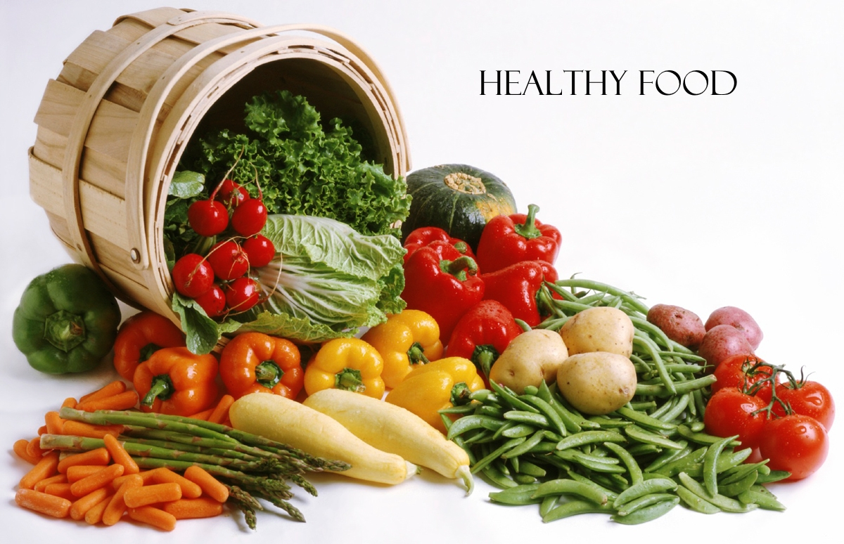

This Issue:

***By:* Abeer Suleiman * * * Menatalla EL-Mallah**

**Sara AL-Bulushi * * * Rawan AL-Hinai**

*Under the supervision of Ms. Rasha Ghanem*

We would like to introduce you to our new weekly magazine “Future Stars” which is created by:

Abeer Suleiman …………………….. 7D

Mennatalla El-Mallah…………….. 7D

Rawan Al-Hinai……………………….. 7A

Sara Al-Bulushi………………………… 7D

*Under the supervision of Ms. Rasha Ghanem*

This week’s topic is going to be about healthy food.

We hope that you will be entertained reading our new magazine.

***☺***

**Greetings…**

***Teacher’s Word***

SLC: Ms. Rasha Ghanem

“A healthy life style starts with healthy eating. Refer to the food pyramid to arrange your meals, and

make sure you have three meals per day. By eating

healthy you can get all the nutrients necessary for

your body to get energy and grow, and it also

prevents sickness and disease.

Stay Healthy ☺”

HEALTHY FOOD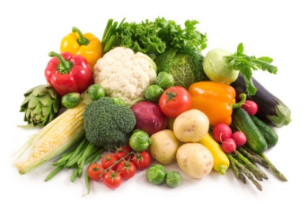

People often think of healthy eating as an all or nothing proposition, but a key foundation for any healthy diet is moderation. But what is moderation? In essence, it means eating only as much food as your body needs. You should feel satisfied at the end of a meal, but not stuffed. Moderation is also about balance. We all need a balance of carbohydrates, protein, fat, fiber, vitamins, and minerals to sustain a healthy body.

The goal of healthy eating is to develop a diet that you can maintain for life, not just a few weeks or months, or until you've hit your ideal weight. For most of us, that means eating less than we do now. More specifically, it means eating far less of the unhealthy junk foods (refined sugar, saturated fat, for example) and replacing it with healthy treats (such as fresh fruit and vegetables). However, it doesn't mean completely eliminating the foods you love. Eating bacon for breakfast once a week, for example, could be considered moderation if you follow it with a healthy lunch and dinner—but not if you follow it with a box of donuts and a sausage pizza. If you eat 100 calories of chocolate one afternoon, balance it out by deducting 100 calories from your evening meal. If you're still hungry, fill up with an extra serving of fresh vegetables.

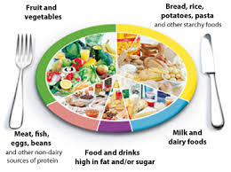

Fruits and vegetables are the foundation of a healthy diet. They are low in calories and nutrient dense, which means they are packed with vitamins, minerals, antioxidants, and fiber. Unfortunately, most people are falling short of the recommended daily minimum of five servings of fruit and vegetables. In fact, most of us need to **double** the amount we currently eat.

Try to eat a rainbow of fruits and vegetables every day and with every meal—the brighter the better. Colorful, deeply colored fruits and vegetables contain higher concentrations of vitamins, minerals, and antioxidants—and different colors provide different benefits, so eat a variety. Aim for a minimum of five portions each day. Try adding berries to breakfast cereals, eating fruits as a healthy dessert, and snacking on vegetables such as carrots, snow peas, or cherry tomatoes instead of processed snack foods.

* **Greens:**Branch out beyond bright and dark green lettuce. Kale, mustard greens, broccoli, and Chinese cabbage are just a few of the options—all packed with calcium, magnesium, iron, potassium, zinc, and vitamins A, C, E, and K.
* **Sweet vegetables:** Naturally sweet vegetables—such as corn, carrots, beets, sweet potatoes, yams, onions, and squash—add healthy sweetness to your meals and reduce your cravings for other sweets.
* **Fruit:** Fruit is a tasty, satisfying way to fill up on fiber, vitamins, and antioxidants. Berries are cancer-fighting, apples provide fiber, oranges and mangos offer vitamin C, and so on.

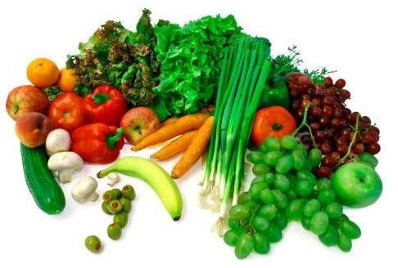

* This article is from: [www.helpguide.org](http://www.helpguide.org)

***Healthy eating aDVICE***

***Healthy eating and drinking is an important part of looking after your health. Here are some easy tips to help you to follow a healthy balanced diet.***

**Nutritional Deficiency Diseases**

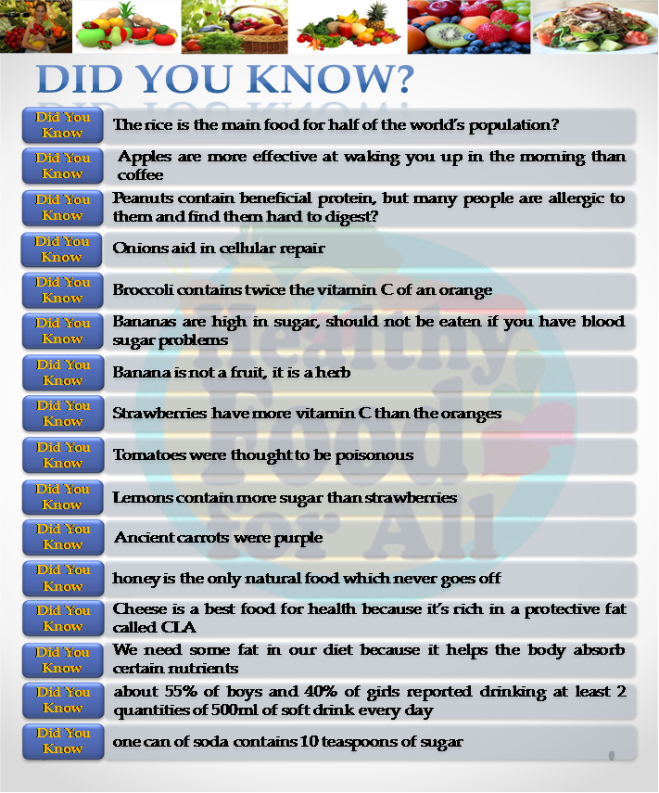

WATCH OUT FOR THE NEXT EDITION!!!!!!!



